FIRST MORNING STAR BAPTIST CHURCH SCHOLARSHIPS APPLICATION
8906 Guinea Road, Post Office Box 159
Bena, Virginia 23018
(804) 642-2390
https://www.firstmorningstarbena.net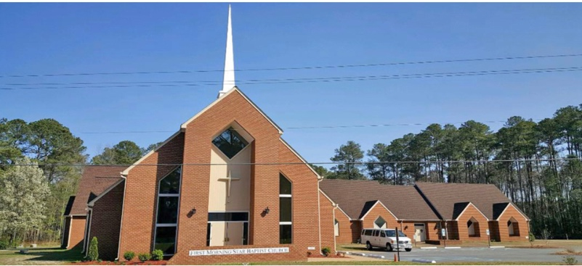

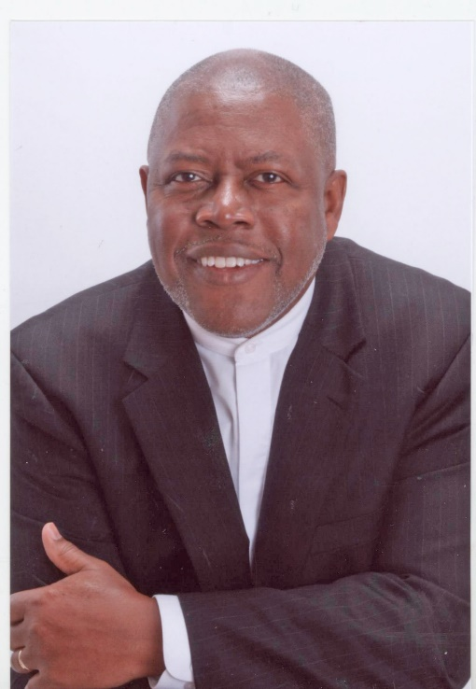

PASTOR, REVEREND LARRY ARRINGTON

The James T. Tonkins and Linda J. Bolden Scholarship APPLICATION

PART I- PERSONAL CONTACT INFORMATION:
Name: __________________________________________________________________
Home Address: ___________________________________________________________
Phone: __________________________________________________________________
Email: __________________________________________________________________
Date of Birth: _____________________________________________________________
Parent/Guardians Names: __________________________________________________
Parent/Guardians Phone Number:____________________________________________
________________________________________________________________________
PART- II: HIGH SCHOOL/ INFORMATION:
Name of High School/Post Graduate: ________________________________________________________________________________________________________________________________________________
Graduation Date:__________________________________________________________
Extracurricular activities you participated in:____________________________________ ________________________________________________________________________________________________________________________________________________
________________________________________________________________________
PART III- HIGHER EDUCATION AND CAREER GOAL:
Provide name and location of the University, College, or Training School you plan to attend: ________________________________________________________________________________________________________________________________________________
PROOF OF ADMISSION: Submit written acceptance showing name of school and name of applicant.
Major or Training you are pursuing: _______________________________________________________________________________________________________________________________________________
Provide a typed essay of a minimum of 150 words of your career goals:______________
________________________________________________________________________
________________________________________________________________________
Name of Church:__________________________________________________________
Address:__________________________________________________________________________________________________________________________________________
Pastor:__________________________________________________________________
Your Favorite Scripture:_____________________________________________________
__________________________________________________________________________________________________________________________________________________Your Church activities: ______________________________________________________ __________________________________________________________________________________________________________________________________________________
PART V- TWO LETTERS OF RECOMMENDATION REQUESTED:
A. Church: Pastor; Sunday School Superintendent; Youth Choir, or Usher Director, or Mentor
B. High School Principal; Assistant Principal, Teacher from whom you took a class; School Counselor, Athletic Coach, or Academic Advisor

Signature of Applicant:____________________________________Date____________
All application material must be completed and received no later than June 1, 2022. Send application, addendums or questions to: FirstMorningStar@HRCoxmail or
Mail application to:
FIRST MORNING STAR BAPTIST CHURCH
ATTN: Scholarship Ministry
8906 Guinea Road, Post Office Box 159
Bena, Virginia 23018

